LAB 1
Activity Practice 1: Requirements Elicitation
1. Actors
Actor | Describe
Web Customer | Customers register, log in, and make purchases online.
Administrator | Administrators manage products, orders, and users.
Payment Gateway | Third-party payment systems process transactions.

2. Functional Requirements (Top 5 cho Web Customer)
STT | Functional requirements | Describe
FR1 | Register / Log in | Customers create an account or log in to use the system.
FR2 | Search and filter products | Search by name, filter by brand, price, category
FR3 | View product details | View photos, description, price, size, and stock availability.
FR4 | Shopping Cart Management | Add, edit quantity, or remove products from the cart.
FR5 | Order & Payment | Enter the delivery address, confirm the order, and pay via COD.

3. Non-Functional Requirements (NFRs)
Type | Request | Specific targets
Performance | The system must be able to handle a large number of simultaneous users during peak hours. | Supports 10,000 simultaneous users, with a response time of under 2 seconds.
Security | User data and transactions must be protected. | Password encryption, JWT authentication, HTTPS connection
Available | The system must operate continuously, with as few interruptions as possible. | Uptime is 99.9%, and it automatically recovers when a service fails.

4. Architecturally Significant Requirements (ASRs)
ASR 1: Scalability (NFR - Performance)
Item | Content
Request | The system must be able to handle 10,000 simultaneous users during peak hours.
Impact | Architecture must be used.MicroserviceEach service (Product, Order, Cart) can scale independently without scaling the entire system. A Load Balancer is needed to distribute the load.

ASR 2: Data Security (NFR)
Item | Content
Request | Account and transaction information must be fully protected.
Impact | Cup Auth ServiceSeparate system for authentication. Uses JWT tokens to control access between services. Passwords are encrypted using bcrypt, and connections are HTTPS.

ASR 3: System Availability (NFR)
Item | Content
Request | The system must operate continuously, even if one component fails.
Impact | Microservice architecture ensures that services are independent of each other.Product ServiceThe error does not follow.Order ServiceFailure. Use Database Transactions to ensure data consistency when placing orders.

Activity Practice 2: Use Case Diagram
2.1 General use case diagram of the entire system
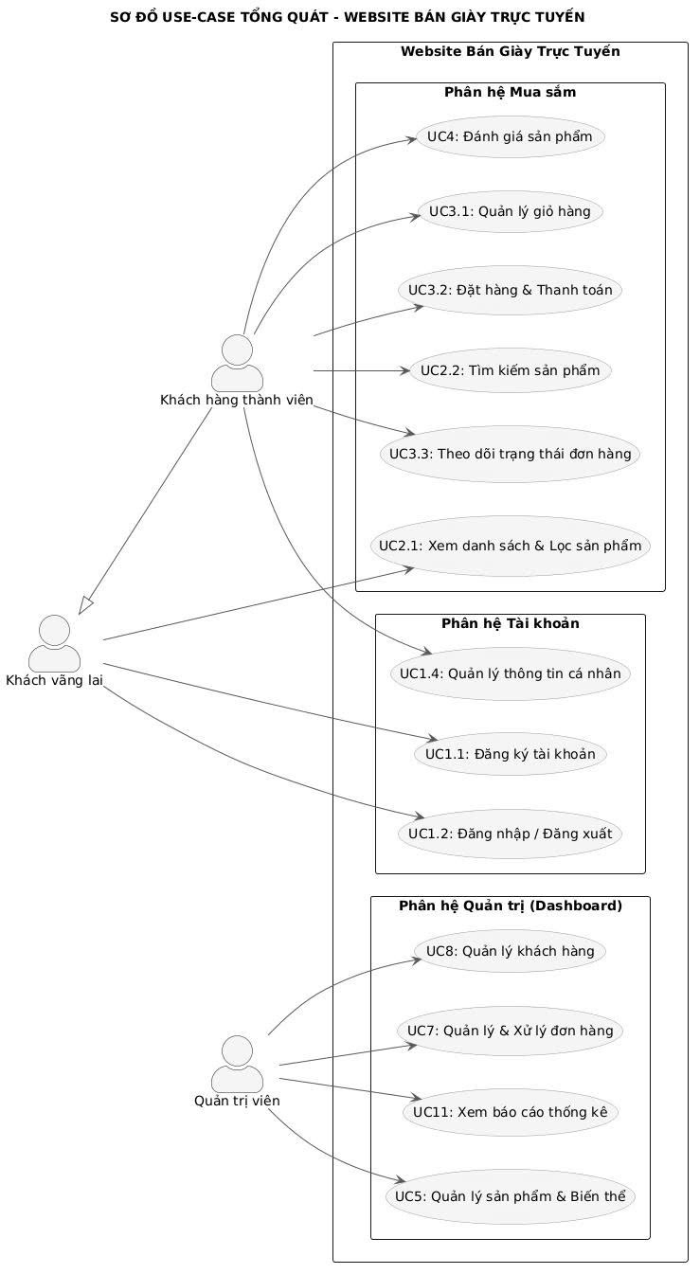
2.2 Order Management Use Case Diagram

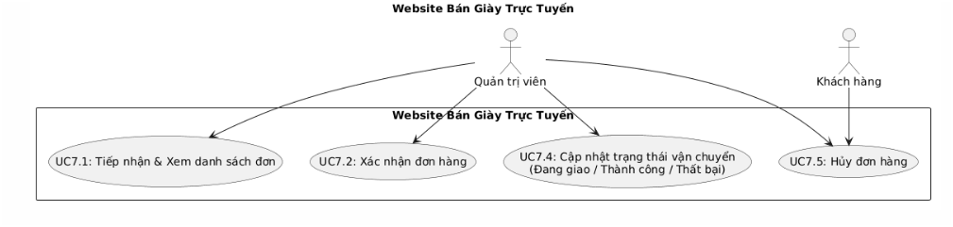
2.3 Use Case Diagram: Admin's Product Management
